

**b-side festival 2018**

**OPEN CALL COMMISSIONS BRIEF**

**One amazing island …..**

b-side is offering a number of commission opportunities to create new, temporary, site-responsive work in any media for the next festival, 8 - 16 September 2018. Proposals can be for any amount up to £4000 - we expect to commission work across a range of contexts, concepts and costs. An additional allowance of up to £760 per commission is available towards travel and accommodation.

**Deadline for applications is 9am Monday 6 November 2017.**

The b-side biennial festival commissions site-responsive work for public spaces on Portland revealing aspects of the island environment and communities and their relationship to elsewhere.

Located just off the coast of Dorset and approached via a narrow causeway, this curious island has a very particular history and ecology offering huge scope for research and inspiration. We are looking for ideas that respond to and reveal all aspects of the island, which may include its geology, ecology, archaeology, heritage and its geographic relationships locally and internationally.

The festival takes place over a nine day period with installations and events at a number of locations across the island. This year we are encouraging visitors to explore by foot using public rights of way and public transport where possible and are seeking proposals in response to a number of specific sites - listed below. We also welcome proposals for locations nearby or on route to these locations or proposals about the footpaths themselves.

Proposals for artworks and interventions should be site-responsive and temporary, exploring the fabric, history or contemporary use of the place and aim to intrigue and engage audiences. Work can be for indoor or outdoor contexts, intimate or large scale, static, mobile, durational or event based.

Proposals should be for new work but may be part of a larger or on-going project.

Applications are invited from artists working in any media including: visual art, digital, sound, film, text based work, live and performance art, social media and socially engaged practice.

The commissions will form the core programme of the festival with artists also contributing to talks and other events.

Artists will be selected on the basis of an outline proposal and will then have further opportunity to research and develop the final work.

The selected artists will have access to curatorial support, installation assistance, venue facilitation and help with finding accommodation. Artists will also have the opportunity of using our b-side shop front ‘project space’ - Outpost, in Fortuneswell, Portland for use as private or public facing research, meeting or work space and engagement venue prior to the festival.

Each commission opportunity includes an introductory residential period on Portland in March 2018 allowing the selected artists to research and develop their final proposal. This initial residential period will provide opportunities to get to know the area with talks, walks and introductions to communities and individuals that artists might work with. Artists will have the opportunity for individual exploration of Portland as well as contributing to discussions between the curatorial team and selected artists.

Successful applicants will be expected to attend the initial residential research days and a minimum of 4 days during the 2018 Festival. An allowance of up to a total of £760 per commission is available towards expenses for this initial research trip, additional visits, installation/de-installation of work and attendance for 4 days during the festival. Past festivals have shown us that audiences and artists get much more out of the experience if the artist is present with their work and able to engage with visitors during the festival.

**Locations**

Artists are encouraged to develop work for any of the following sites, places on route **or** the paths that link them.

The named sites are:

**Chiswell Community Garden**

<http://www.portlandhistory.co.uk/chiswell-walled-garden.html>

**The Esplanade and Quiddles café, Chiswell**

<http://www.portlandhistory.co.uk/chesil-cove.html> <http://www.geoffkirby.co.uk/Portland/680730/#Esplanade>

**High Angle Battery**

<http://www.portlandhistory.co.uk/verne-high-angle-battery.html>

<http://www.geoffkirby.co.uk/Portland/690730/#HighAngle>

**Fancys Farm**

<http://www.portlandhistory.co.uk/fancys-family-farm.html>

[www.fancysfarm.co.uk](http://www.fancysfarm.co.uk)

**The Engine Shed**

<http://www.portlandhistory.co.uk/the-old-engine-shed.html>

**The Governors Community Garden** (The Grove)

<http://www.portlandhistory.co.uk/governors-community-garden.html>

**Easton Gardens**

<http://www.geoffkirby.co.uk/Portland/690715/#Gardens>

<http://www.portlandhistory.co.uk/easton-gardens.html>

**St Georges Church**

<http://www.portlandhistory.co.uk/st-georges-church.html>

<http://www.geoffkirby.co.uk/Portland/685720/#StGeorgesChurch>

**Portland Bill area**

<http://www.geoffkirby.co.uk/Portland/675680/>

<http://www.portlandhistory.co.uk/portland-bill.html>

<http://www.portlandhistory.co.uk/ministry-of-defence-magnetic-range.html>

<http://www.portlandhistory.co.uk/culverwell-mesolithic-site.html>

**Link to map** showing Portland with footpaths in pink <https://explorer.geowessex.com/?layers=48,403&basemap=26&x=369155.22&y=70510.20&epsg=27700&zoom=15>

This Dorset Explorer website mapping system is also useful for exploring many different layers of information on Portland.

Additional sites will be developed and negotiated in discussion with artists in response to commission proposals.

**More info on Portland:**

<http://www.portlandhistory.co.uk/map-and-a-z-index.html>

<http://www.geoffkirby.co.uk/Portland/IndexMap/>

**HOW TO APPLY**

Applications must be made online via Curatorspace applications portal: <https://www.curatorspace.com/opportunities/detail/open-call-for-bside-festival/1637>

Your proposal may be submitted EITHER in writing using the online form OR as a video recording uploaded to YouTube or Vimeo. The link for this must be part of your application.

If you cannot make an application online then please contact [amanda@b-side.org.uk](mailto:amanda@b-side.org.uk) for alternative options.

**Your application will need to include the following - either in writing OR video (max length 10mins):**

* A brief summary of your idea (250 words max)
* A more detailed description of your proposed idea (500 words max)
* Proposed location
* Amount applied for and outline budget
* The resources and technical support you will need access to
* A summary description of your practice (300 words)
* Images (10 max) or weblinks illustrating your proposal and /or previous work

**Deadline: Applications to be submitted no later than 9am Monday 6 November 2017**

* All applications will be acknowledged on receipt.
* All shortlisted artists will be notified by 23 November and invited to an interview (via Skype) 27 or 28 November 2017
* We regret it is not possible to notify or give feedback for unsuccessful applications

**Summary info**

* Commissions offer **up to** £4000 to make work for the b-side 2018 festival. This covers the artist fee and all costs including materials, production, installation and de-installation of work and any additional travel and accommodation over the allowance budget.
* An additional allowance of up to £760 per commission will be payable towards expenses for initial research and additional visits, installation/de-installation of work and attendance for 4 days during the festival.
* We expect to commission across a range of budgets with a maximum of 3 awards at the £4000 level.
* Artists may submit up to three ideas at varying costs within the £4000 commission budget maximum. Please submit a separate application for each idea.
* Applicants are welcome to bring additional funding from other sources to support their proposal or for proposals to be part of a larger/on-going piece of work.

**Please note selected artists will be:**

* Required to attend the initial residential research days in March 2018 (dates to be confirmed
* Available for 4 days during the 9 day festival period of 8 - 16 September 2018 (not including installation/de-installation days)
* Expected to play an active part in audience engagement with their work as part of their research and development or during the festival.
* Responsible for transportation, installation/de-installation of their work

[www.b-side.org.uk](http://www.b-side.org.uk)

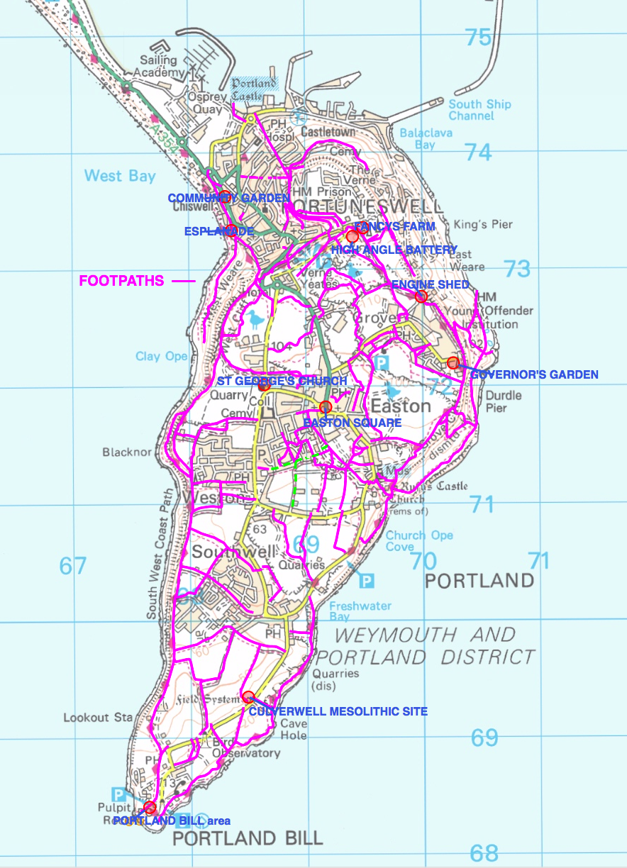

Map showing principal location options plus footpaths.

Visit the Dorset Explorer website to explore Portland in more detail

<https://explorer.geowessex.com/?basemap=26&x=369238.75&y=72916.38&epsg=27700&zoom=15>