 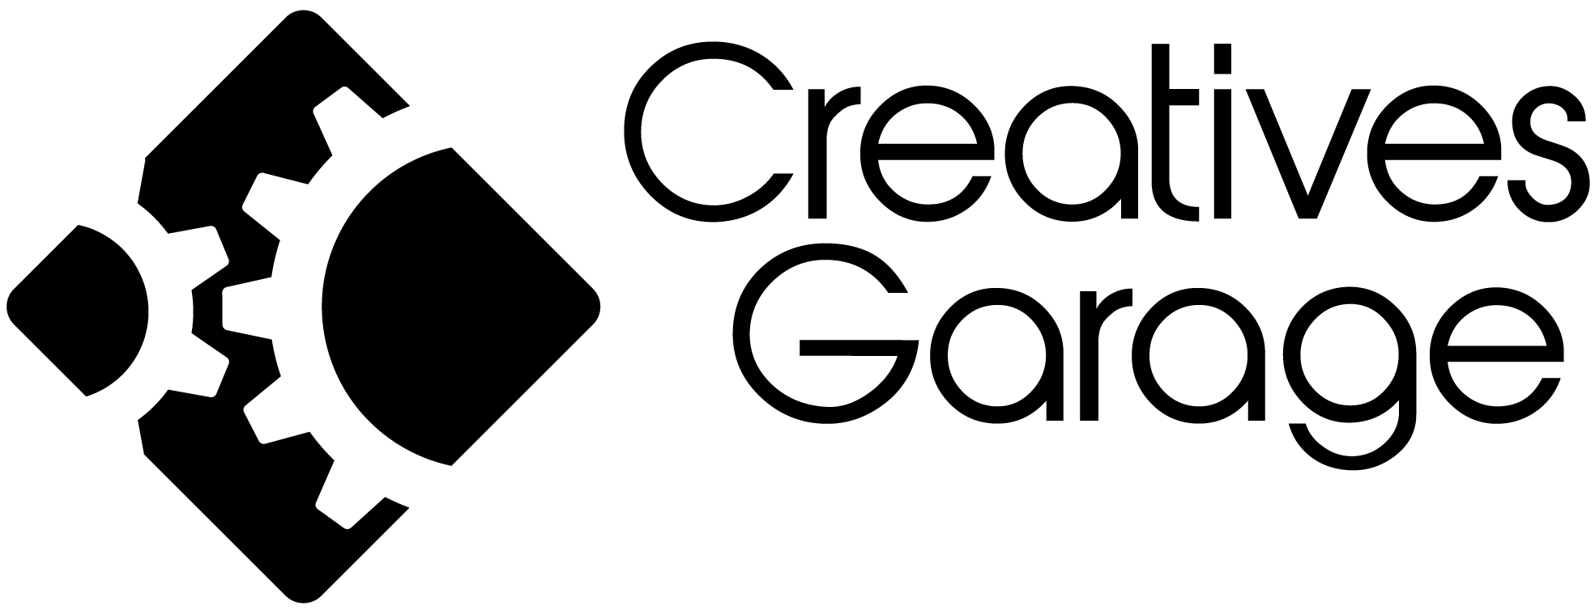 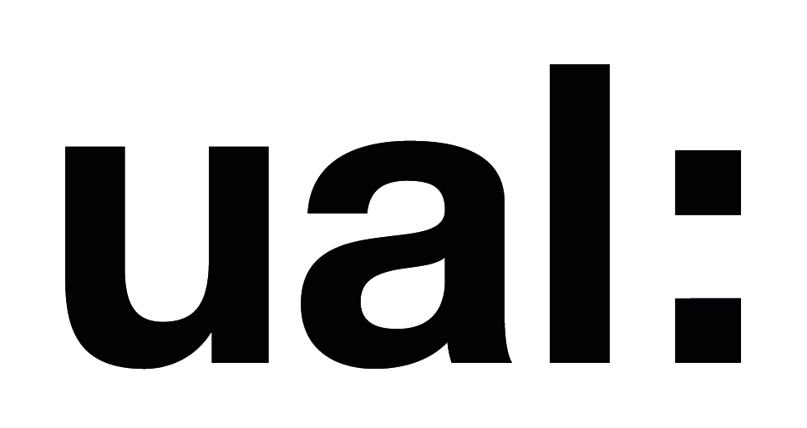

**THATOTHER.PLACE 2022 | OPEN CALL**

**£10K (GBP) ARTIST COMMISSION**

**MEDIA: EXTENDED REALITY**

**DEADLINE FOR APPLICATIONS: 12 APRIL 2022**

**ACCESS**

If you require this information in a different format or have any access requirements at all, do not hesitate to contact b-side’s Access lead [molly@b-side.org.uk](mailto:molly@b-side.org.uk)

If you have any questions about the Open Call in general then please contact: [sandy@b-side.org.uk](mailto:sandy@b-side.org.uk)

**OPEN CALL BRIEF - INTRODUCTION**

We are offering a commission opportunity for a queer identifying artist or arts collective to create an extended reality artwork responding to the theme of Common Lands.

Proposals can be for any amount up to £10,000 (GBP). This fee is to include your artist(s) fee, production and material costs, all installation and tech costs.

This Open Call for a new artwork is a co-commissioning process between b-side (Dorset), Creatives Garage (Nairobi), and London College of Communications (London).

**What we are looking for:**

* Proposals by a queer identifying artist(s) or an artist collective in the mediums of: augmented reality, virtual reality, and mixed reality.
* Artworks that respond to the people and/or place of the Isle of Portland. We do not expect or require that you have visited the Isle of Portland but that there is an interest to engage with either the place or concept of the Isle of Portland. For example, what does living on an island mean, both physically, mentally, emotionally? How do macro global concerns play out with a small island community? How might island communities such as the Isle of Portland retain their remoteness and yet stay intimately connected to others? Is there a relationship between queer and island identities? Please note we are looking for responses to this brief that are as equally about the Isle of Portland as about your perspective on the questions we are proposing.
* A new artwork that can be experienced by audiences both in the physical world (at b-side festival 2022 on the Isle of Portland, Dorset) and the digital world. Your artwork can of course reach audiences elsewhere too!
* We are excited to understand how your artwork engages audiences. We are therefore keen to understand how your proposal considers the user/viewer experience of - or even interaction with - your artwork. We are keen for you to take into account audiences that might have limited broadband speeds when trying to access any online components of your artwork. In general, we are very keen to ensure this artwork considers accessibility of a diversity of people.
* We expect that all artworks will be ready to be viewed for the b-side festival which runs from the 8th - 11th September 2022, both on the Isle of Portland and online.
* We are requesting the selected artist/artist collective join one online/or in person welcome session with all b-side’s 2022 Festival artists and communities in June 2022. And that the selected artist/artist collective gives an online/or in person artist talk or question and answer session during b-side Festival 2022.
* All commissioning partners are committed to minimising our environmental impact. We encourage you to consider the carbon footprint related to the production, materials, installation, and any activities as part of your project proposal.

**Who the opportunity is for:**

* An individual artist or an artist collective. If you are applying as an artist collective you don’t need to be formally incorporated but you will need to have a bank account that we can pay into on behalf of the collective. And we will need you to nominate one contact person within the collective who has overall responsibility for the artist agreement (including budget and timelines).
* An artist or artist collective from:

**Algeria, Argentina, Bangladesh, Brazil, China, Colombia, Egypt**, **Ghana, India, Indonesia, Iraq**, **Jordan, Kenya**, **Lebanon, Malaysia, Mexico, Morocco, Myanmar, Nepal, Nigeria**, **Occupied Palestinian Territory, Pakistan, Peru, Philippines**, **South Africa, Sudan**, **Thailand, Tunisia, Turkey**, **Ukraine, and Vietnam.**

You do not have to be living in the country you are from when applying. For example, you could be a Kenyan artist living in the UK and be eligible to apply.

* A queer identifying artist or artist collective. We understand this is a broad and expansive term. For this Open Call we are offering a commission for an artist or artist collective who identifies as Lesbian, Gay, Bisexual, Intersex, Asexual, Pansexual, Non-Binary, Bigender, Genderqueer, Transgender, Queer.
* An artist or artist collective who would like to make a work that might not be able to be made in their own country. The medium of extended reality and the exploration of digital worlds, as well as exhibiting on the Isle of Portland, is therefore useful for freedom of expression, queerness, and creativity.
* We deeply value diversity and are working to make our application and commissioning process accessible to all. We welcome proposals from those currently underrepresented in the arts and particularly from disabled artists. We will endeavour to work with artists to mitigate barriers to making their work for the festival. We welcome access documents from artists at any stage of the process. Some more info on access documents <https://www.accessdocsforartists.com/>
* If there is to be an online component to your work, it can be hosted at [www.ThatOther.Place](http://www.thatother.place) You are welcome to use this domain name and platform in any way you like, or not at all.

**CONTEXT**

b-side is a festival and arts organisation based on the Isle of Portland, Dorset, UK. The island is the beating heart that inspires b-side’s work, but our projects and opportunities extend way beyond its boundaries. Our next festival, b-side 2022, is taking place from the 8th - 11th September 2022.

Our curatorial theme is 'Common Lands'. The Isle of Portland becomes a microcosm to explore relationships to and with land. We invite international artists, island residents, and creative researchers to create projects inspired by our environmental commonalities: climate justice, biodiversity, erosion. As well as our human commonalities: migration, displacement, land ownership.

*ThatOther.Place* is both a programme and a proposition to ‘Common Lands’. Is our current land adequately hosting everyone? Does this land have the resources needed to embrace our commonalities and our differences? *ThatOther.Place* becomes a testing ground - a playground - to explore new worlds and ways we might live together.

ThatOther.Place 1.0 was created and developed by Creatives Garage, a queer led arts collective based in Nairobi Kenya. The team created a parallel online world to the Isle of Portland. The world, Creatives Garage tells us, was discovered by a group of miners when they were working in Portland’s famous stone quarries - they heard music and laughter coming through the thick stone walls. Creatives Garage’s ThatOther.Place is a world full of radical love and care, it is a place that successfully utilises creativity to challenge racism, homophobia, and gender based violence. You can view their world here: [**www.creativesgarage.org/that-other-place**](https://www.creativesgarage.org/that-other-place)

ThatOther.Place 2.0 now invites queer identifying artists and/or arts collectives from the following countries (either citizens of these countries or citizens of these countries living elsewhere) to create a new extended reality artwork which will be exhibited during b-side festival 2022.

**Algeria, Argentina, Bangladesh, Brazil, China, Colombia, Egypt**, **Ghana, India, Indonesia, Iraq**, **Jordan, Kenya**, **Lebanon, Malaysia, Mexico, Morocco, Myanmar, Nepal, Nigeria**, **Occupied Palestinian Territory, Pakistan, Peru, Philippines**, **South Africa, Sudan**, **Thailand, Tunisia, Turkey**, **Ukraine, and Vietnam.**

**The below outlines full details on how to apply for this Open Call.**

**HOW TO APPLY**

Applications must be made online via this Curatorspace applications portal [APPLY HERE](https://www.curatorspace.com/opportunities/detail/that-other-place--digital-open-call/6177)

If the brief outlined above aligns with your artistic practice and you would like to submit a proposal, please complete the online application form OR submit a video/audio recording supplying the following information (more info on this below):

* A brief summary of your/your arts collective’s idea (approx. 200 words or 1.5 min video/audio recording)
* A detailed description of your/your arts collective’s idea (up to 1,000 words or 7min video/audio recording)
* A summary of your/your arts collective’s practice (approx. 500 words or 4 minutes video/audio recording)
* How you envisage audiences engaging with the work you are proposing (approx. 500 words or 4 minutes video/audio recording)
* How your proposed artwork will be experienced on the Isle of Portland and at b-side Festival, 8th - 11th September 2022. (approx. 500 words or 4 minutes audio/video recording)
* Any technical support you/your arts collective’s will need to show your work at b-side Festival 2022.
* Amount you/your arts collective’s are applying for and a budget breakdown showing how the funds will be spent. ***Budget headings: Artist Fee / Materials and/or Technology / Installation costs on the Isle of Portland / Other***
* Images or weblinks illustrating your/your arts collective’s proposal and/or previous work.
* Kindly note, on the application form you/your arts collective will be asked a few details about you in relation to the country you are from/applying from and how you/your arts collective identifies.

**IF YOU WOULD PREFER TO SUBMIT YOUR PROPOSAL BY VIDEO/AUDIO**

As well as written proposals, we can also accept audio and video responses too.

If you want to submit your proposal via video or audio, please record your video/ audio responses and save each short video on Youtube/Vimeo/ Google Drive/Dropbox, and then add the link to the video within the Curatorspace form (where the text response would usually go). The questions which you should answer in your recording are listed above. Please remember to include any password for password protected links.

If you cannot make an application on the online portal CuratorSpace then please contact [molly@b-side.org.uk](mailto:molly@b-side.org.uk) for alternative options.

**EQUALITY MONITORING**

We are collecting information from artists applying for this opportunity for reporting purposes to funders and to find out who we are reaching and who is missing. You will find these questions in the Curatorspace application form.

**PROPOSAL TIMELINE**

|  |  |
| --- | --- |
| Open Call Live | Tuesday 8th March 2022 |
| All proposals due by | 9am BST, Tuesday 12th April 2022 |
| Shortlisted artists notified by | Wednesday 20th April |
| Interviews | Monday 25th and Tuesday 26th April |
| Notification of Outcome and Artist Agreement | Friday 29th April |
| Creation of Art | 1st May - 31st August 2022 |
| Work ready for sharing | End of August 2022 |
| b-side Festival dates | 8 - 11 Sept 2022 |
| Feedback and reflection session | Week of 19th September 2022 |

Please note:

* Artists will be selected on the basis of their initial proposal and will then have further opportunity to research and develop the final work if they are selected.
* There will be an opportunity for support from partners, London College of Communications and Creatives Garage, in the form of consultancy on UX (user experience), content production, and technical guidance.
* All applications will be acknowledged on receipt.
* All unsuccessful applications will be notified at earliest opportunity.
* We regret due to our limited team capacity it is not possible to give feedback to all unsuccessful applications however we aim to give feedback to all shortlisted applicants that are selected to interview.

**ABOUT THE COMMISSIONING PARTNERS**

**b-side** commissions site-responsive work for public spaces on the Isle of Portland, Dorset (UK) revealing aspects of the island, its environment and communities that are often overlooked. We commission artworks that speak to this magical place, and to our island’s relationship to elsewhere. We commission work that is thoughtful, maverick, subversive, poetic or just simply delicious looking. The artworks we commission come together over a 4 day period, every September. Check out our website to see more about what we do, how we work, and also more about the magical Isle of Portland [www.b-side.org.uk](http://www.b-side.org.uk)

**Creatives Garage** is an arts organization based in Nairobi Kenya. We conceptualize, create, and distribute content fed by African narrative. We film scripts written by undiscovered talent, publish books by revolutionary women, host art exhibitions, record and distribute podcasts and music. We also develop tools that embrace emerging and existing tech to build the Kenya Creative community.

Creatives Garage focuses majorly on being a creative agency that will focus on creating strategic engagement in culture collateral and processes with creative brand audiences. We will strive to be the only art society in Kenya that promotes the use of art to showcase the interconnection of various aspects in human activity to relay emotions, struggles and inspire the society to cope and overcome the society’s challenges.

**London College of Communication (LCC)**, is a pioneer in creative communications education. Part of University of the Arts London (UAL) its Design School is a multidisciplinary community of internationally recognised educators, researchers and practitioners.

**FURTHER INFORMATION ON B-SIDE FESTIVAL 2022**

* b-side takes place over a four day period with installations and events at a number of locations across the Isle of Portland - a tied island based off the South coast of Dorset, in England.
* New artworks/commissions form the core programme of b-side with artists also contributing to talks and other events prior to or during the festival.
* Proposals for artworks and interventions are temporary. We are interested to see if the work you propose is also site responsive to somewhere on the Isle of Portland, and we list below a selection of sites on the island as well as further research links that may be of interest to you.
* We welcome proposals that involve working with Isle of Portland residents and festival visitors as individuals or groups for more intimate, reflective artworks and interactive encounters.
* Proposals should be for new work but may be part of a larger or on-going project.
* We expect artworks to have a presence throughout b-side festival 2022 or if event based to include a number of performances or audience opportunities.
* Applications are invited from artists/arts collectives at any career stage.
* This commission offers up to £10,000 to make work for the b-side 2022 festival. This covers the artist(s) fee and all costs including all materials for production, installation and deinstallation of work online and on the Isle of Portland.
* Applicants are welcome to bring additional funding from other sources to support their proposal if it is greater in ambition than our commission levels allow.
* The selected artist / artist collective must either be physically present or available online for the 4 days of b-side festival 2022. Past festivals have shown us that audiences and artists get much more out of the experience if the artist is present with their work and able to engage with visitors during the festival.

* If and where appropriate, the selected artist / artist collective will have access to curatorial support, installation assistance, venue/site facilitation. Artists will also have the opportunity of using our b-side shop front project space - ‘Outpost’, in Fortuneswell, on the Isle of Portland for use as private or public facing research, meeting or work space and engagement venue prior to the festival.

**FURTHER CONTEXT AND INFORMATION**

**Information about the Isle of Portland, Dorset, UK**

Portland is a curious island with a very particular history and ecology offering huge scope for research and inspiration. Located in the South West of England just off the coast of Dorset and approached via a narrow causeway, this hulk of limestone, bounded by steep cliffs and treacherous seas is unlike anywhere else in Dorset. Prior to the first road bridge built in 1839 linking it to the mainland, it was an isolated agricultural community sustained by farming and fishing and with its own unique ways and customs. Many ancient land use and management practices continued long after joining the mainland. However Portland has been dramatically changed and influenced over the years by quarrying and military appropriation and secret experimentation, resulting in what is now widely regarded as an industrial landscape and economy. It is a small island just 1.7 miles across and 4 miles long, it’s coastal edges subject to the forces of nature, eroded by the sea, landslips and rock falls, its interior removed by quarrying and mining. With an ever-increasing population, space is at a premium and land use contested. As policies of growth and the impact of climate change collide, the opportunities to develop a sustainable community are challenged. More recently tourism is seen as the growth industry, as former quarries are re-wilded as nature reserves and Portland’s unique ecological, historical and leisure attractions are increasingly recognized by climbers, divers, walkers, bird watchers, naturalists, geologists and historians. Portland, as a community and place, encapsulates in miniature the characteristics of what is happening in a wider world context

**ISLAND SITES AND RESEARCH LINKS**

These are just a few examples of sites and venues used for previous festivals as well as Information about Portland and its history and geology

**High Angle Battery**

<http://www.portlandhistory.co.uk/verne-high-angle-battery.html>

<http://www.geoffkirby.co.uk/Portland/690730/#HighAngle>

**Chiswell Community Garden**

<http://www.portlandhistory.co.uk/chiswell-walled-garden.html>

**The Esplanade and Quiddles café, Chiswell**

<http://www.portlandhistory.co.uk/chesil-cove.html> <http://www.geoffkirby.co.uk/Portland/680730/#Esplanade>

**Fancys Farm**

<http://www.portlandhistory.co.uk/fancys-family-farm.html>

[www.fancysfarm.co.uk](http://www.fancysfarm.co.uk)

**The Engine Shed**

<http://www.portlandhistory.co.uk/the-old-engine-shed.html>

**The Stadium Bowl**

<https://www.portlandhistory.co.uk/portland-stadium-bowl.html>

<http://www.geoffkirby.co.uk/Portland/695725/#Sports>

**The Governors Community Garden** (The Grove)

<http://www.portlandhistory.co.uk/governors-community-garden.html>

**Easton Gardens**

<http://www.geoffkirby.co.uk/Portland/690715/#Gardens>

<http://www.portlandhistory.co.uk/easton-gardens.html>

**St Georges Church**

<http://www.portlandhistory.co.uk/st-georges-church.html>

<http://www.geoffkirby.co.uk/Portland/685720/#StGeorgesChurch>

**Portland Bill area**

<http://www.geoffkirby.co.uk/Portland/675680/>

<http://www.portlandhistory.co.uk/portland-bill.html>

<http://www.portlandhistory.co.uk/ministry-of-defence-magnetic-range.html>

<http://www.portlandhistory.co.uk/culverwell-mesolithic-site.html>

**More info on Portland:**

<https://www.portlandhistory.co.uk/introduction.html>

<http://www.geoffkirby.co.uk/Portland/IndexMap/>

This Dorset Explorer website mapping system is useful for exploring many different layers of information on Portland.

<https://explorer.geowessex.com/>

**End.**