**Artist Brief for THIS LAND: Brandy Row**

Expressions of Interest invited from artists experienced in community engagement, co-creation and socially engaged practice, for a commission on the Isle of Portland, Dorset as part of a Heritage Lottery funded project called This Land.

**Fee:** £4,000 plus travel & accommodation allowance

**Materials:** additional budget of up to £2000 for materials and equipment

**Deadline:** 25 April 2022

**Commission Details**

b-side is inviting expressions of interest from artists or artist collaborations who have social engagement and site sensitivity at the heart of their practice, for a commission working with the community in response to the site of a ruined cottage on the seafront facing Chesil Beach on the Isle of Portland, Dorset as part of a Heritage Lottery funded project called This Land.

**This Land Project**

This Land is a two year project exploring and celebrating the unique natural and built heritage of the isle of Portland, Dorset and responds directly to community concerns about their environment. Exploring land use and access, land and property rights, biodiversity and climate change, the project aims to raise awareness, gather and share knowledge, and upskill and empower the community to protect and enhance their environment.

The project focuses on two ‘at risk’ sites and aims to reach those who might not usually get involved in heritage. The two sites are the remains of a Tudor cottage in Brandy Row on the seafront at Chiswell and the last remaining area of unquarried/agricultural landscape at Portland Bill.

The project programme includes activities and discussion events exploring the biodiversity and history of Portland, and will open up conversations around threats and opportunities for the Island. What does the future hold for these sites? How does an island adapt to environmental change? How do we best enhance and protect our environment? Our aim is to encourage, facilitate and support a dialogue that gives a voice to different points of view, whilst also researching and documenting existing built and natural environment heritage. A key project activity will involve residents in research activities to discover and uncover histories, gather data, learning new skills in the process. Artist commissions will respond to and interpret the community led research and create artworks/activities/dialogue engaging a wide range of people, sharing knowledge, and raising awareness of environmental issues for residents and visiting audiences.

**See additional background info Appendix A below**

This brief is for artist/artist collaboration to work in response to the Brandy Row site, Chiswell.

The Brandy Row site is an area of council owned land currently used for fishing stores. Once a row of Tudor stone and thatch cottages, the buildings were heavily damaged by storms and allowed to deteriorate since. However, the remains of one of the cottages still stands. Working with the community, a Research Facilitator and artists we will explore the past of this site, capture any stories and record memories, creating an archive of the site and its context on Portland. What is the story of this building? What can we uncover about the past? We will focus on exploring laws, customs, property rights and the effects of climate change on this vulnerable coastal seafront position. Situated in an at risk area with sea levels rising – can this building be saved and what innovative ideas might we explore for its future? What are the options that support and preserve this prominent part of Portland as a community asset?

The This Land project starts in May 2022 with a Research Facilitator supporting community led research exploring both sites. A public event on Sat 18 June will share the initial research with a wider audience. The research will also be shown in some form during our festival 8-11th Sept 2022.

This commission is for an artist/s to work alongside and/or in response to the community led research and the issues described above relating to the Brandy Row site and context. The artist/s work will develop activities that extend the community reach beyond the research group and engage those who might not usually get involved in cultural projects.

We are open to artists working in any medium whose creative process includes various methods, stages or outcomes such as: collaboration or co-creation, works in progress, sharing of process to a visiting audience, final artistic outcome and reflection process. As part of their work we would like artists to incorporate a form of consultation that captures residents and visitor ideas for the future use of this site as a community asset. Residents that currently use the site for storing fishing gear would be encouraged to participate and contribute to this future vision that would include their storage arrangements continuing in some form.

b-side will introduce the artist/artists to our network of partners and residents on the island, to community groups or individuals who are interested in the project and to venues for workshops etc. and to act as a sounding board for creative elements of the project where required.

Key partners for the Brandy Row site are The Portland Building Preservation Trust.

Key dates for project activities and outcomes can be negotiated but should include either a final outcome OR sharing of work in progress at b-side’s festival September 08 -11, 2022, with the option of a further or final opportunity for sharing in September 2023.

**Timeline:** Project period April 2022 – September 2023

Community research period with facilitator: May/June 2022

Public display/presentation/engagement events: 18 June 2022 and 8 – 11, Sept 2022, also June and September 2023

**Fee:** £4,000 plus travel & accommodation allowance

**Materials:** additional budget of up to £2000 for materials and equipment (depending on agreed proposal)

**Deadline for applications**: 25 April 2022

**b-side**

We are a cultural organisation based on Portland, b-side’s ethos is to develop projects that sustain or enhance the distinctive geographical character of a place - its environment, heritage, aesthetics, culture, and wellbeing of residents. b-side commissions artists from all disciplines to make site specific artworks and community engagement projects in response to the Isle of Portland and showcases the work in a festival format. We work with communities to uncover histories and hidden narratives, which are shared widely across physical and digital platforms.

**Environment**

b-side are committed to minimising our environmental impact. We encourage everyone we work with to consider the carbon footprint related to any activities as part of their work with us, including to re-purpose or recycle all materials from workshops, exhibitions, installations and performances.

**Diversity**

b-side values diversity and are working to make our application and commissioning process accessible to all. We welcome proposals from those currently under-represented in the arts and encourage disabled artists to apply. We will endeavour to work with artists to mitigate barriers to making their work for the festival. We welcome access documents from artists at any stage of the process. Some more info on access documents can be found here: <https://www.accessdocsforartists.com/>

**HOW TO APPLY**

Open to individuals and/or partnerships/collaborations. Artists should have sound experience of socially engaged practice and be confident in working with diverse participants with various experiences of arts projects.

We are asking for expressions of interest initially - a final proposal will be agreed with b-side following a short period of research and development.

Applications must be made online via CuratorSpace: <https://www.curatorspace.com/opportunities/detail/this-land-open-call/6192>

 You will need to create a free 'basic' CuratorSpace account before you can submit your proposal (CuratorSpace is a great way to find other opportunities as well).

Please complete the online application form with the following information:

* An expression of interest outlining your interest in this work
* A summary covering your approach and potential ideas for this project
* A summary description of your practice
* images or weblinks links to examples of your work /projects or experience

As well as written responses, we can accept audio and video responses too. If you want to submit responses to any of the above via video or audio, please record your video / audio response, save it on Youtube/Vimeo/ Google Drive/Dropbox, and then add the link to the video within the CuratorSpace form (where the written response would usually go). **Max video length 7 mins total**

**Any queries please contact:** amanda@b-side.org.uk

**Access**  
Please let us know if you need any of the information in a different format. Additionally, please contact us if there is anything we can do to make the application process more accessible to you.

For further support email Molly Scarborough (b-side's Access lead): molly@b-side.org.uk

**Deadline:** Applications to be submitted no later than 25 April 2022

* All applications will be acknowledged on receipt.
* Interviews (online) for shortlisted applicants are provisionally scheduled for during week commencing 9 May 2022
* We regret it is not possible to give feedback to all unsuccessful applications, however we will endeavour to offer feedback to unsuccessful applicants who were shortlisted

[www.b-side.org.uk](http://www.b-side.org.uk)

Project supported by Heritage Fund, Arts Council England, Kestrelman and Valentine Trust and Diversity Art Forum

**APPENDIX A: Background Information**

**The Isle of Portland**

Portland is a curious island with a very particular history and ecology. Located just off the coast of Dorset and approached via a narrow causeway, this hulk of limestone, bounded by steep cliffs and treacherous seas is unlike anywhere else in Dorset. Prior to the first road bridge built in 1839 linking it to the mainland, the island was an isolated agricultural community sustained by farming and fishing and with its own unique ways and customs. Many ancient land use and management practices continued long after joining the mainland.

However this once sheep grazed landscape of limestone grassland has been dramatically changed and influenced over the years by quarrying, military appropriation and secret experimentation, resulting in what is now widely regarded as an industrial landscape and economy. Despite this Portland retains some extraordinary environments and rare species.

It is a small island just 1.7 miles across and 4 miles long, it’s coastal edges subject to the forces of nature, eroded by the sea, landslips and rock falls, its interior removed by quarrying and mining. With an ever-increasing population and industrial expansion space is at a premium and land use contested. As policies of growth and the impact of climate change collide, the opportunities to develop a sustainable community are challenged. More recently tourism is seen as the growth industry, as former quarries are re-wilded as nature reserves and Portland’s unique ecological, historical and leisure attractions are increasingly recognized by climbers, divers, walkers, bird watchers, naturalists, geologists and historians. Portland, as a community and place, encapsulates in miniature the characteristics of what is happening in a wider world context

**Common Lands**

This Land is part of our Common Lands programme - exploring our relationship to and with land – both here and elsewhere. This includes the physical and environmental context, together with the human and social context. Incorporating biodiversity, climate change, migration, displacement, land use, access, ownership, and rights. Common Lands will work with artists and communities to explore these interwoven themes in relation and in response to the site and context of Portland. We will do this through three programmes created in conversation with Portland communities:

**This Land** - focusing on heritage and environment.

**Who Do We Think We Are?** - focusing on people and migration,

**That Other Place** - focusing on digital lands and alternative identities.

**This Land Study Sites**

**Brandy Row, Chiswell**

At the northern end of Portland where the lower slopes of the island meet chesil beach is the village of Chiswell. On the seafront here is a small plot of council owned land currently used for fishing stores. In one corner sits the derelict remains of a row of thatch and stone Tudor cottages that once ran along this road facing directly out to sea bearing the brunt of winter storms and floods. In very poor state of repair, with no listing or historical surveys, chances to research and save this potential community asset decrease with the pressure for demolition and council asset sell off.

Working with the community we will explore the past of this site, capture any stories and record memories creating an archive of the site and its context on Portland. What is the story of this building? What can we uncover about the past? Situated in an at risk area with sea levels rising – can this building be saved and what possibilities are there for the future of this site?

We will focus on exploring laws, customs, property rights and the effects of climate change on this vulnerable coastal seafront position. What are the options that support and preserve this prominent part of Portland as a community asset?

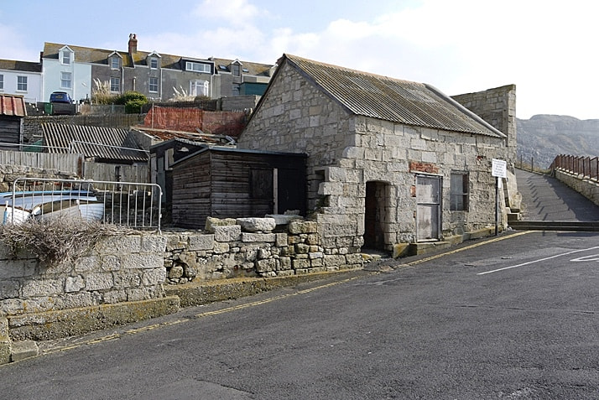

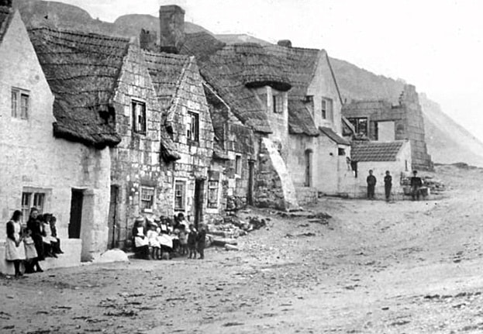

https://www.portlandhistory.co.uk/chiswell.html

what3words ///earliest.asserts.overlaps

**The Portland Bill landscape area – from Southwell to the Bill**

Due to quarrying this is now the only significant area of the island where the original land surface and substrate remains. This small portion of the island is rich in heritage and biodiversity. Here traces of Portland’s agricultural past remain, with ancient strip field systems still visible. There is also evidence of prehistoric occupation, including the site of a Mesolithic settlement (currently on Historic England’s Heritage at Risk register). Portland's limestone geology and coastal location has resulted in very particular environmental conditions that support and attract some diverse and rare plants and wildlife and the project will have a particular focus on the biodiversity of this area. Existing mineral extraction permissions and pressure of commercial development are a real and continuing threat. Working with the community we will explore Portland's farming past, the history of land use, the meanings of the various designations of land access and protections.

https://www.portlandhistory.co.uk/portland-bill.html