**Research Facilitator Brief for THIS LAND**

**Brief for Research Facilitator** to lead on a programme of community research exploring the unique natural and built heritage of the Isle of Portland, Dorset as part of a Heritage Lottery funded project called This Land.

**Summary**

b-side is seeking a Research Facilitator to lead a programme of community led research exploring the unique natural and built heritage of the Isle of Portland.

This freelance position includes developing and delivering activities working with community groups. To investigate and gather knowledge about two study sites and their wider context - training and guiding participants in research, using archives and recording oral histories in the process.

The Research Facilitator will conduct and support research, collate material gathered and share with the public, write site reports and contribute to evaluation of the project.

This role is open to individuals and / or partnerships / collaborations.

**Fee:** £7k + travel and accommodation allowance

**Deadline: 5pm**, **4 April 2022**

**About This Land**

This Land is a project exploring and celebrating the unique natural and built heritage of the Isle of Portland, Dorset and responds directly to community concerns about their environment. Exploring land use and access, land and property rights, biodiversity and climate change, the project aims to raise awareness, gather and share knowledge, and upskill and empower the community to protect and enhance their environment.

The project focuses on two ‘at risk’ sites and aims to reach those who might not usually get involved in heritage. The two sites are the remains of a Tudor cottage on the seafront in Chiswell and the last remaining area of unquarried/agricultural landscape at Portland Bill.

See additional background info in Appendix A below.

**Project activities**

Workshops and discussion events will explore the biodiversity and history of Portland and open up conversations around threats and opportunities and how the sites can be best protected and enhanced. Our aim is to encourage, facilitate and support a dialogue that gives a voice to different points of view, while also researching and documenting existing built and natural environment heritage,

A key project activity will involve residents in research activities to discover and uncover histories, gather and record data, learning new skills in the process. Artist commissions will respond to and interpret the community led research and create artworks / activities / dialogue engaging a wide range of people, and share knowledge, and raise awareness of environmental issues for residents and visiting audiences.

Project research material, reports and documentation will be collated and deposited with community organisations and appropriate archive organisations, including Dorset History Centre, Portland Heritage Centre and Portland Museum - creating valuable resources for future use by communities.

**b-side**

We are a cultural organisation based on Portland. b-side’s ethos is to develop projects that sustain or enhance the distinctive geographical character of a place - its environment, heritage, aesthetics, culture, and wellbeing of residents. b-side commissions artists from all disciplines to make site specific artworks and community engagement projects in response to the Isle of Portland and showcases the work in a festival format. We work with communities to uncover histories and hidden narratives, which are shared widely across physical and digital platforms.

**The Brief**

This brief is for a Research Facilitator to lead on the community research aspect of the This Land project.

We are looking for an individual or team with experience in heritage research, using archives and working with diverse communities. The Research Facilitator/s will work in close collaboration with and be supported by the This Land project team.

The Research Facilitator/s will develop and run a series of outdoor/ indoor workshops involving working directly with the sites and archives, including recording oral histories and other opportunities for people to learn research skills, share, knowledge, collect memories and stories. Participants will be drawn from local communities and recruited through existing community contacts and word of mouth plus editorial in local press.

The Research Facilitator/s will undertake research and oversee and guide individual and / or collaborative research to uncover histories, gather and record knowledge about each site. They will collate all information gathered, share with the commissioned Artists and wider public through displays and talks, they will also write site reports and contribute to evaluation of the project.

The main tasks for the Research Facilitator will be during the early phase of the project in May - September 2022.

Summary of Research Facilitator tasks:

* Devise, manage, and lead a programme of research focused on each site, involving residents of Portland. Sessions may include:
  + Walks and site visits
  + Research skills
  + Using archives
  + Recording residents memories and stories
* Provide short updates that can be shared publicly
* Collate and record all research material and provide written summary of knowledge gathered for each site
* Facilitate display of research material (June and Sept 2022)
* Facilitate access to research material for commissioned Artists
* Provide project and site reports/research in a format suitable for deposition at local archive centre
* Contribute to evaluation of project
* Ensure best practice in working with community groups
* Liaise with Project Director, Project Manager and commissioned Artists

**Details:**

**Fee:** £7,000 plus travel & accommodation allowance

**Days/hours:** Freelance position with days/times to be determined by the project plan as developed by the Research Facilitator/s and agreed with b-side.

**When:** Project period April 2022 – September 2023

The main tasks for the Research Facilitator will be during the early phase of the project in May - September 2022.

Research workshop activity: May/June 2022

Display/Presentation: 18 June 2022 and early Sept 2022

First stage reports: Sept 2022

Final reports April 2023

The Research Facilitator/s will have excellent project management and delivery skills that enable them to run multiple projects at the same time and to produce articles to tight deadlines. The Research Facilitator/s will have an understanding of research methodologies and be confident working with groups of mixed age, skills and abilities. Their experience in directing research and delivery with community groups will help participants learn how to conduct research and gain knowledge and confidence.

b-side are committed to minimizing our environmental impact. We encourage everyone we work with to consider the carbon footprint related to any activities as part of their work with us, including to re-purpose or recycle all materials from workshops, exhibitions, installations and performances.

b-side values diversity and are working to make the application and commissioning process accessible to all and endeavour to work to mitigate barriers. We welcome access documents from applicants at any stage of the process. More info on access documents https://www.accessdocsforartists.com/

**How to Apply**

We welcome applications from individuals or partnerships/collaborations.

Please format your application as a single document if possible (preferably PDF) and send via email to: amanda@b-side.org.uk

**Your application will need to include the following**

* An expression of interest outlining your interest in this work and the skills and experience you will bring to the project.
* A summary plan of action covering your approach to this project and potential workshop plan or ideas.
* A CV and /or links to websites or examples of your work /projects or experience
* Confirmation of your availability in May/June/ and Sept 2022

**Access**  
Please let us know if you need any of the information in a different format.

Additionally, please contact us if there is anything we can do to make the application process more accessible to you.

For further support email Molly Scarborough (b-side's Access lead): molly@b-side.org.uk

**Deadline: Applications to be submitted no later than 5pm 4 April 2022**

* All applications will be acknowledged on receipt.
* We regret it is not possible to notify or give feedback for unsuccessful applications
* Interviews for shortlisted candidates will take place online using zoom during week beginning 11 April 2022

Any queries please contact:

[amanda@b-side.org.uk](mailto:amanda@b-side.org.uk)

07816 224015

[www.b-side.org.uk](http://www.b-side.org.uk)

Project supported by Heritage Fund, Arts Council England, Kestrelman and Valentine Trust

and Diversity Art Forum

**APPENDIX A: Background Information**

**The Isle of Portland**

Portland is a curious island with a very particular history and ecology. Located just off the coast of Dorset and approached via a narrow causeway, this hulk of limestone, bounded by steep cliffs and treacherous seas is unlike anywhere else in Dorset. Prior to the first road bridge built in 1839 linking it to the mainland, the island was an isolated agricultural community sustained by farming and fishing and with its own unique ways and customs. Many ancient land use and management practices continued long after joining the mainland.

However this once sheep grazed landscape of limestone grassland has been dramatically changed and influenced over the years by quarrying, military appropriation and secret experimentation, resulting in what is now widely regarded as an industrial landscape and economy. Despite this Portland retains some extraordinary environments and rare species.

It is a small island just 1.7 miles across and 4 miles long, it’s coastal edges subject to the forces of nature, eroded by the sea, landslips and rock falls, its interior removed by quarrying and mining. With an ever-increasing population, space is at a premium and land use contested. As policies of growth and the impact of climate change collide, the opportunities to develop a sustainable community are challenged. More recently tourism is seen as the growth industry, as former quarries are re-wilded as nature reserves and Portland’s unique ecological, historical and leisure attractions are increasingly recognized by climbers, divers, walkers, bird watchers, naturalists, geologists and historians. Portland, as a community and place, encapsulates in miniature the characteristics of what is happening in a wider world context

**Common Lands**

This Land is part of our Common Lands programme - exploring our relationship to and with land – both here and elsewhere. This includes the physical and environmental context, together with the human and social context. Incorporating biodiversity, climate change, migration, displacement, land use, access, ownership, and rights. Common Lands will work with artists and communities to explore these interwoven themes in relation and in response to the site and context of Portland.

We will do this through three programmes created in conversation with Portland communities:

**This Land** - focusing on heritage and environment.

**Who Do We Think We Are?** - focusing on people and migration,

**That Other Place** - focusing on digital lands and alternative identities.

**This Land Study Sites**

**The Portland Bill landscape area** (Southwell to the Bill)

Due to quarrying this is now the only significant area of the island where the original land surface and substrate remains. This small portion of the island is rich in heritage and biodiversity. Here traces of Portland’s agricultural past remain, with ancient strip field systems still visible. There is also evidence of prehistoric occupation, including the site of a Mesolithic settlement (currently on Historic England’s Heritage at Risk register). Portland's limestone geology and coastal location has resulted in very particular environmental conditions that support and attract some diverse and rare plants and wildlife and the project will have a particular focus on the biodiversity of this area. Existing mineral extraction permissions and pressure of commercial development are a real and continuing threat. Working with the community we will explore Portland's farming past, the history of land use, the meanings of the various designations of land access and protections.

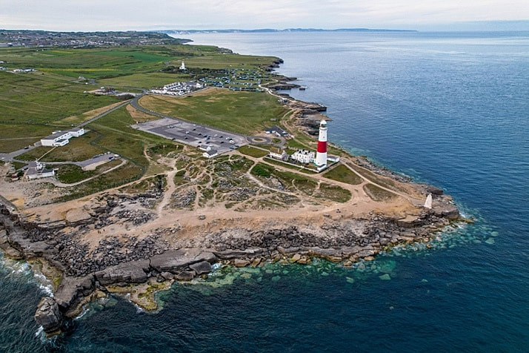

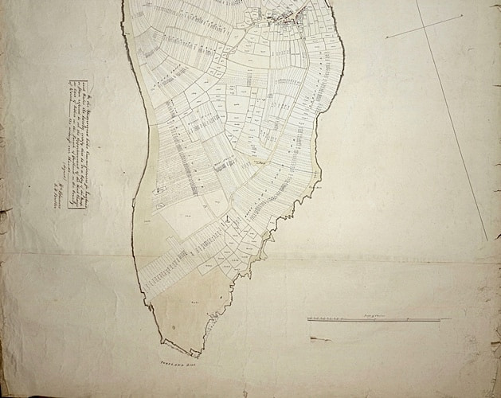

https://www.portlandhistory.co.uk/portland-bill.html

**Brandy Row** , Chiswell

The Brandy Row site is an area of council owned land currently used for fishing stores. Once a row of Tudor stone and thatch cottages, the buildings were heavily damaged by storms and allowed to deteriorate since. However the remains of one of the cottages still stands. In very poor state of repair, with no listing or historical surveys, chances to research and save this locally loved building and potential community asset decrease with the pressure for demolition and council asset sell off.

Working with the community we will explore the past of this site, capture any stories and record memories creating an archive of the site and its context on Portland. What is the story of this building? What can we uncover about the past? Situated in an at risk area with sea levels rising – can this building be saved and what possibilities are there for the future of this site?

We will focus on exploring laws, customs, property rights and the effects of climate change on this vulnerable coastal seafront position. What are the options that support and preserve this prominent part of Portland as a community asset.

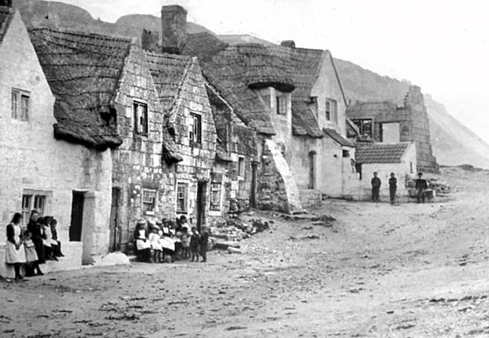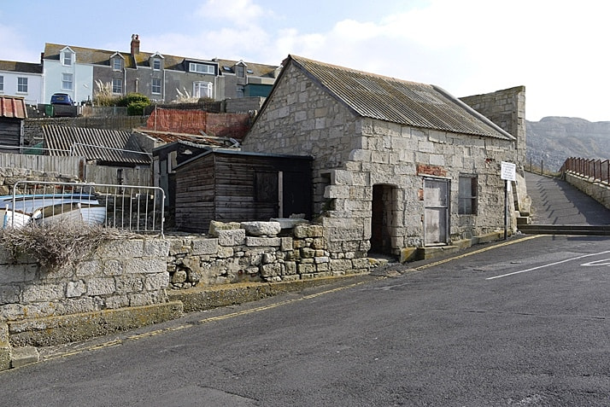

https://www.portlandhistory.co.uk/chiswell.html

What3words ///: ealiest.asserts.overlaps